

**<<Bird meal order System>>**

**Software Design Document**

**Table of Contents**

**I. Overview**

1. Introduction

2. System Functions

3. Entity Relationship Diagram

4. Common Requirements

II. Functional Requirements

1. <<Feature Name 1>>

a. <<Function Name 1>>

b. <<Function Name 2>>

2. <<Feature Name 2>>

**I. Overview :**

1. **Introduction:**

The online bird food shopping system is a new Web application that replaces the real-life selection processes, making it easy for customers to choose and pay conveniently. With a diversified product development system, customers do not have to go to the place to choose, but can stay at home and comfortably choose suitable models for themselves. This system is expected to develop after updates with new features and promises to be completed as soon as possible to introduce to consumers.

**2. Code packages**

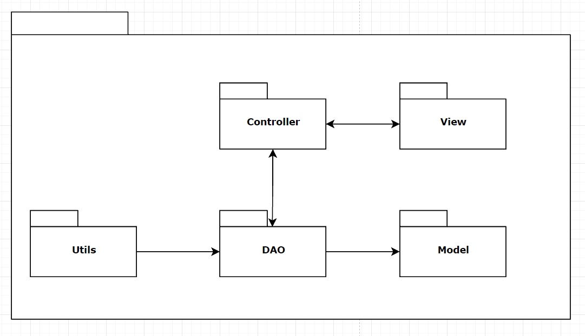

| **No** | **Package** | **Description** |
| --- | --- | --- |
| *01* | *Controller* | *Acts as a go-between for the service layer and the Front-end, passing on different input requests*  *<Class naming convention>* |
| *02* | *DAO* | *This component is used to get data directly FROM the database*  *<Class naming convention>* |
| *03* | *Utils* | *This component helps connect database*  *<Class naming convention>* |
| *04* | *Model* | *This component includes interfaces used to receive data retrieved FROM the database and classes used to receive data*  *<Class naming convention>* |
| *05* | *View* | *This component display front-end*  *<Class naming convention>* |

**3. Datatable schema**

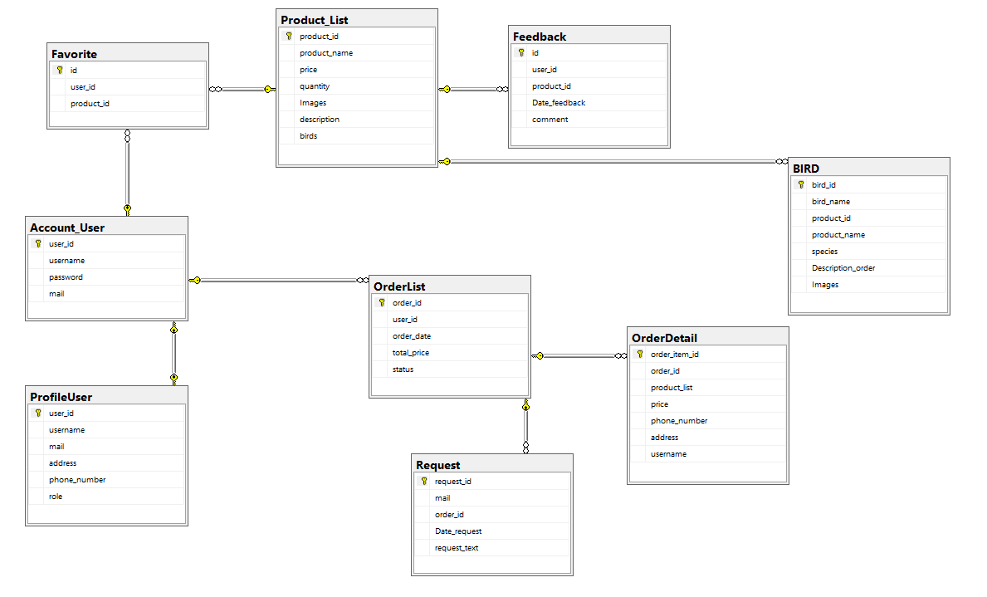

II. Code Design

1. Customer / Add To Favorite

Class Diagram

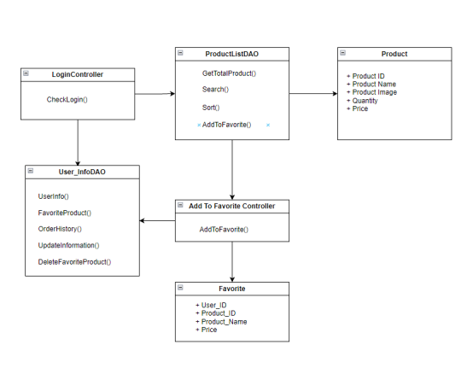

Sequence Diagram

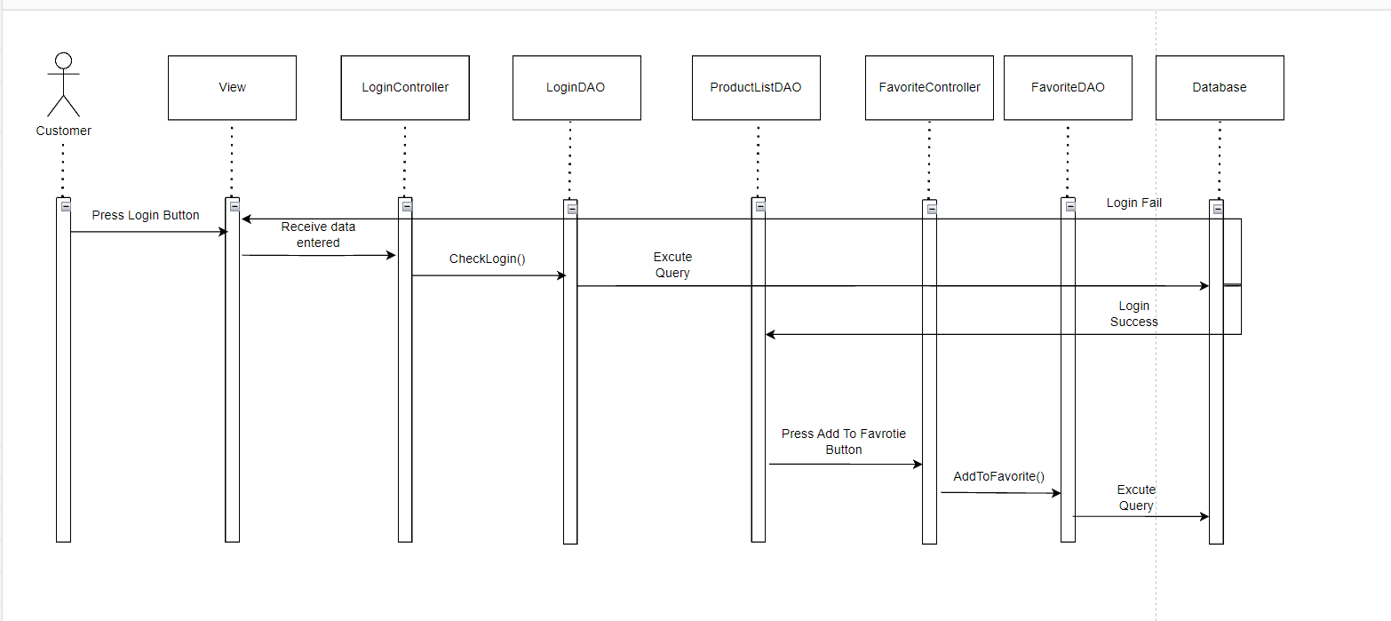

2. Common / Reset password

1. Diagram

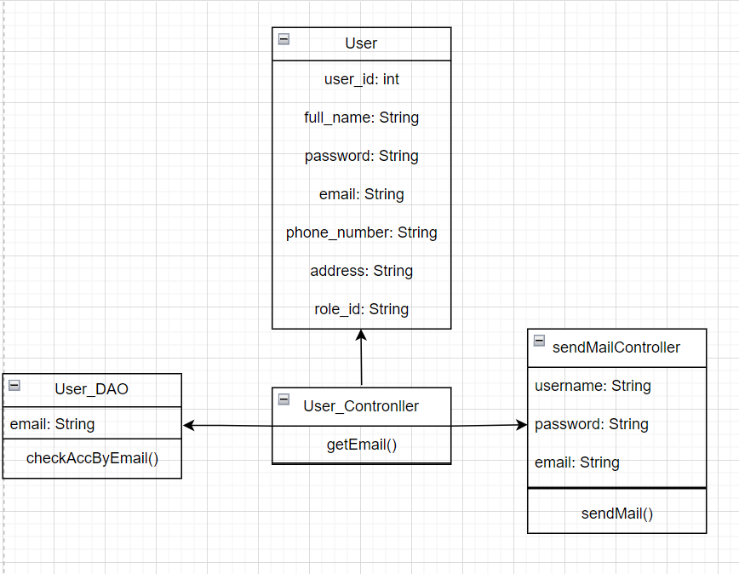

**b. Specifications**

| **No** | **Method** | **Description** |
| --- | --- | --- |
| ***01*** | ***getEmail()*** | ***Retrieve the User's Email entered*** |
| ***02*** | ***checkAccByEmail()*** | ***Check email existence*** |
| ***03*** | ***sendMail()*** | ***Send a link that leads the user to the reset password page*** |

c. Sequence Diagram

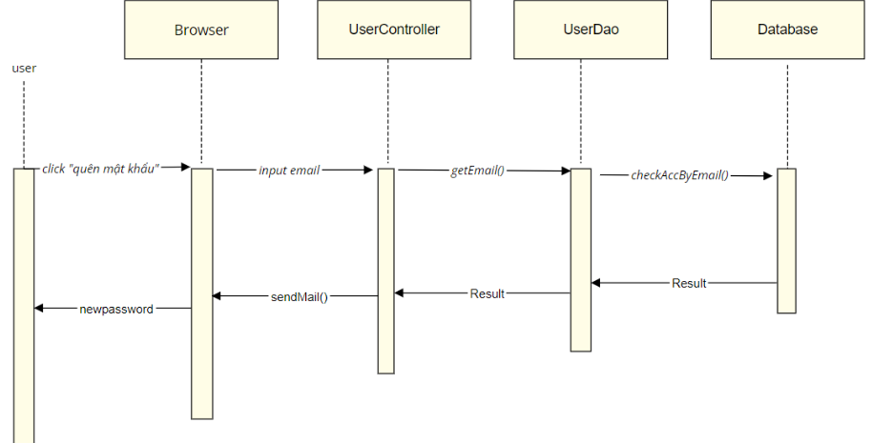

## 3. Public/Products List

### a. Class Diagram

### 

### 

### b. Class Specifications

| **No** | **Method** | **Description** |
| --- | --- | --- |
| 01 | searchProduct() | Search the product by name, letters, etc |
| 02 | sortProduct() | Sort the product by price, quantity, name |
| 03 | getProductDetail() | Get the product details (description, images, customers’ comments,etc) |
| 04 | getBirdDetail() | Get the bird’s details (species, what food they eat, recommended foods) |
| 05 | searchBird() | Search the bird’s by name, letters,etc |

c. Sequence Diagram(s)

